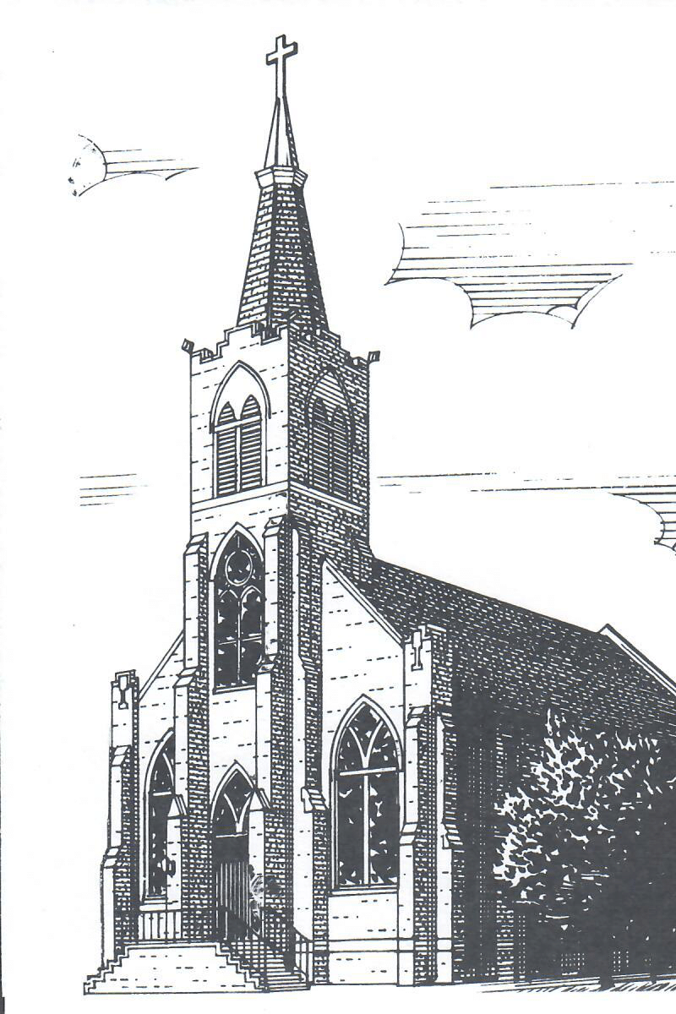
Vol 81 March 22, 2026 No 17
The Fifth Sunday in Lent

VISION STATEMENT: Christ Lutheran Church will continue its Christ-centered, life directed focus, responding to the needs of its members, emphasizing local and worldwide witness, and acting as a catalyst for the improvement of the neighborhood.

HOSPITALIZED:
CONTINUED PRAYERS: Chris Evans, Gary Axelrod, Tina Hill, Denise Buchanan (Linda VonBehren’s sister), Mark Samp, Christine Grebe, Grover Van Dyke, Mary Fran Wessler, Kathy Smith, Mike Schwindenhammer, Chuck Whitehead, Sarah Ly Hang, Charlotte Sparks, Donna Gogele, Louie Heuermann, Joni Bradshaw, Martin Behnke, Linda Samp, Darlene Marvel, Jayme Knapp, Mike Clayton, Roberta Muzzarelli (Jim Grebe’s mother-in-law), Ann Schwindenhammer (sister-in-law of Mike Schwindenhammer), Connie Trunk, Rudy Bozec (brother of Linda Von Behren), for those in the military, for our Church Boards and their members, CLS staff and students, for Christians being persecuted worldwide. THE BOARD OF ELDERS REMINDS YOU that if you have someone you would like to be remembered in The Prayer of the Church during worship on Sundays, send an email to angie.evans@christlutheranpeo.org or call the church office (637-5309). We will renew prayers when requested.
ELDER PRAYING WITH PASTOR : Alan White
ELDERS ASSISTING WITH COMMUNION: Alan White, Del Hume, Tommie Washington
GREETING YOU BEFORE SERVICE TODAY: Stephanie Belvery
ACOLYTES FOR TODAY: Andrew Simmons, Michael VandeVoorde
ACOLYTES FOR NEXT SUNDAY: Kayley Smith, Carter Ferro
AS YOU LOOK FORWARD to your worship next Sunday, you should read the appointed lessons for The Palm Sunday. The First Lesson: Isaiah 50:4-9a, The Second Lesson: Philippians 2:5-11, The Holy Gospel: John 12:12-19.
THE SUNDAY SCHOOL LESSON FOR TODAY: “Trophy Winner”/2nd Article Apostles’ Creed. FEBRUARY PERFECT ATTENDANCE: Robin Abatie, Gary & Suzanne Heinz, Bill Nelson, Jane Grebe, Nancy Knoll, Tommie Washington, Linda Wenzel, Louis & Hilda Knief, Reg Lee, Mike & Kathy Lelm, Martha Guppy; Kindergarten: Rufus Grebe; Second Grade: Aidan Grebe; Third Grade: Nora Abatie; Helpers: Luke & Jana Grebe, Sue Lee.
LAST WEEK: Tithes and offerings: $5,920.00; MTD: $24,567.00 Improvement Fund: $50.00; MTD: $545.00. Church Attendance: 116, N-2nd: 3, 3rd-7th: 3, 8-HS: 3, Adults: 50, Visitors: 1, Total: 60.
VIEW AND CHEW - This Wednesday. Join us as, we continue with “House of David”. Bring your lunch! Invite your friends! Drinks and snacks will be provided. Please call Alan White with questions.
THIS IS THE 17th SUNDAY OF OUR PLEDGE YEAR
STEWARDSHIP CORNER: Romans 8:1 – “There is therefore now no condemnation for those who are in Christ Jesus.” This is the joy of the Gospel! There is no condemnation for us before the throne of God because in His love He has provided salvation for us in Christ. We have been set free. We are His children once again, and co-heirs with Christ of all the blessings of heaven. If this does not make us thankful, nothing will!
EASTER BREAKFAST will be served starting at 8 AM Easter Sunday Morning in Gym B of the school. This will be a great way of continuing to celebrate our risen savior with some extended fellowship and to contribute to a financial need. As a result of a sudden government mandate, we have relocated our aftercare program from the Parish Hall to the school building. To ensure everyone’s safety, we have installed a new door monitoring system. This came as an unexpected expense. All proceeds from the breakfast will go to fund this project. Please help us fund the safety of our children and staff.
ONE MORE WEEK TILL WE START BUILDING! It's almost time to start our tabernacle building project! Be sure to have your child come and help us build the tabernacle replica during the 5th Sunday fellowship next week! It'll take us a couple of weeks to finish our project, so be sure to drop by to see our progress!
LILIES FOR EASTER: Only one more week to order! If you would like to donate a lily for the altar for Easter, please contact Sheila Hills (309 218-7300). The cost is $10.00 each.
LWML BIRTHDAY LUNCHEON: The annual Birthday Luncheon will be held on Saturday, April 11th, at noon, in the Community Room. Ladies, mark your calendars! Reservations may be made by contacting Suzanne Heinz, Bonnie Farrell or Nancy Knoll before Monday, April 6th.
IN NOVEMBER THE LUTHERAN CEMETERY BOARD approved some necessary road repairs at a cost of $29,000. To help recover this amount, an anonymous donor has offered a matching amount up to $10,000. Members of Trinity and Christ Lutheran can help their Lutheran Cemetery in this fundraiser. The anonymous giver has given us until March 31st to obtain this amount. This is a great way for our churches to show their support for the operation of their cemetery. Please consider using the envelopes marked for the Lutheran Cemetery which are in your envelope box or in the pew racks.
DIRECTORY CORRECTION: Diane Totten ph# 309 643-0077, Greg Totten ph# 309 696-6656, email: gltotten@comcast.net
PORTALS OF PRAYER AND FAITHFUL LIVING are available at the annex entrance.
MARCH 31ST IS THE DEADLINE to direct your Thrivent Choice Dollars to Christ Lutheran.

THIS WEEK THE LORD WILLING (MAR 23rd – MAR 29th)
MON 03/23: Bell Choir 4:00PM
TUES 03/24:
WED 03/25: Chapel 10:00AM
View and Chew 11:45AM
Choir 6:30PM
THU 03/26:
FRI 03/27:
SAT 03/28: Easter Eggstravaganza 9:00AM
SUN 03/29: Holy Communion 9:00AM
Sunday School 10:15AM
Bible Classes 10:30AM

ONLINE GIVING



2026 BOARD OF ELDERS

Alan White, Chair (309)253-5709
Elder 1 - Email - bikeandbus@gmail.com
Mike Lelm (309)219-4217
Elder 2 – Email - mike.lelm@gmail.com
Tommie Washington (309)648-9626
Elder 3 - No Email
Del Hume (309)635-6700
Elder 4 - Email - humeds@comcast.net
Kirk Wessler (309)256-9093
Elder 5 - Email - k_wessler@yahoo.com
Jeff Otten (309)696-2309
Elder 6 – Email – jrltr@aol.com
Chad Whitehead (309)620-6333
Elder 7 – Email – whiteheadfam4@gmail.com

